**Daily Task Tracker Scope of work document**

Contents

**Introduction** 2

**Work Flow and Scope of Work** 3

**Task Process Flow for Standalone Tasks** 7

**Task Process Flow for Specific Departments** 7

**Task Process for Specific Work Flows** 8

**Timeline and effort** 9

**Technology** 9

**NOTES:** 9

|  |  |  |  |  |
| --- | --- | --- | --- | --- |
| **Prepared By** | **Reviewed By** | **Date** | **Approved By** | **Remarks** |
| Rathin Das | Vruddhi Dutt | 22-Nov-2019 |  |  |

|  |  |  |  |  |
| --- | --- | --- | --- | --- |
| **Version No** | **Remarks** | **Date Changed** | **Approved / Rejected By** | **Remarks** |
| 2.0 | Updated section:   * Employee Starts a Task * Reports and Dashboards   Added section:   * Task Progress | 18-Feb-2020 |  |  |
|  |  |  |  |  |

# **Introduction**

Currently, there are a lot of tasks being done at various levels within the organizations. These tasks are either intra team tasks or inter team tasks. Employees have to track manually the execution and completion of these tasks through mails or manual intervention like phone calls and F2F Meetings.

We propose to create an automated system to track the whole cycle of such tasks, from their allocation to completion.

The software system is called as **Daily Task Tracker**.

Daily Task Tracker is a generic tool that can be used by all the employees in JM Financial, across all entities. Employees from any entity can assign tasks to any employee from other entity as well. Tasks can be assigned to individual or group or self as well.

When an Employee needs to report a problem or make a query, he/she will create a task. The task will have a unique number reference. The task can be classified within a group or topic. This classification will not be definitive but should help in a faster assignment to a concrete supporter who will take care of the problem.

Supporters can re-allocate a task to a different group or topic if they consider that the original allocation was not one properly.

When a task has been completed, the supporter should tag the task as completed because this will trigger the mechanism by which the employee who reported that task will be notified

Employees will be able to closely track the status of their tasks – both - which they have assigned and which are assigned to them. Provision will be kept for upload/download of supporting files.

The Workflow, Scope and tentative timelines are shared in the below sections.

# **Work Flow and Scope of Work**

* Flow Diagram

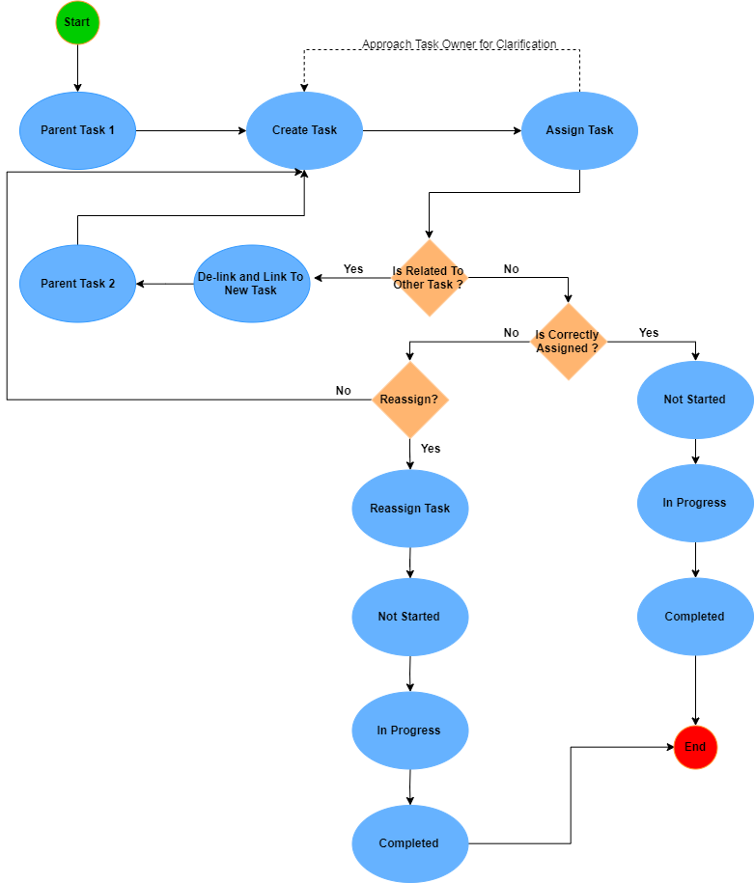

*Exhibit - 1: Flow Diagram*

* Employee Creates a Task
* Single Sign On like all other applications will be followed in this application too.
* An interface will be provided for creating and assigning a task with a TAT.
* The following fields (tentative) will be available of the task layout:
* Subject – Text
* Comments/Task Details – Text Area
* Target Date – Non Mandatory – Date/Calendar
* Priority – Selection Box
* Categories - Selection Box
* Members – Selection Box
* Task Owner – Selection Box
* On Behalf of – Selection Box
* Attachments
* Related tasks will be linked together.
* Reminder option will be provided to the user for every task (Open tasks only).
* While creation of a task, the employee can select particular categories (Not Mandatory). These Categories if selected, will give recommendation of whom the task should be notified. For e.g., If a user selects “Hardware/Networking” category, then the system will recommend CNIT Team for allocating the task. However, the user can supersede the recommendation and select specific employee to allocate the task.
* Once the employee is logged in, he/she will be able to view a dashboard/view listing of all the tasks allocated to him/her, all the tasks he/she has allocated to others with their respective status.
* Email notifications will be triggered to the employee whenever:
* He/she creates a task.
* A task is assigned to him/her.
* He/she reassigns the task to a different person.
* On change of each status of the task.
* Employee Views a Task
* Employee checks the OPEN tasks allocated to him/her.
* Employee will select the Task Status as ‘In Progress’ using which the status of the task will be shown as “In Progress” to both the allocator and to whom the task is allocated.
* Employee on opening a task might find that the task is already done / linked with other task / wrongly allocated to him/her.
* In such cases, the employee will mark the task as “Completed” / “LINK TO EXISTING TASK” / “RE-ASSIGN” etc.
* When the employee reassigns the task to another employee, the task status will be New or Not Started for the second employee. For the first employee the Task Status will be ‘Closed’ or ‘Completed’.
* On the home page of the task the employee will have a view of the task list as shown below.

|  |  |  |  |  |  |  |
| --- | --- | --- | --- | --- | --- | --- |
| **Task ID/Reference Number** | **Subject** | **Owner** | **Assigned To** | **Task Status** | **Start Date** | **End Date** |
| 123 | Documentation | Vruddhi | Rathin | In Progress | 20-Nov-2019 | 25-Nov-2019 |

*Exhibit - 2: Task View Details*

* Two view categories will be provides as listed below.
* *Tasks Created By Me*: The list of tasks created by the employee will be displayed.
* *Tasks Assigned To Me*: The list of tasks assigned to the employee will be displayed.
* The reporting manager will be able to view all the tasks created by and/or assigned to his/her subordinates.
* Every task will have a history view that will show the list of actions taken on that task.

|  |  |  |  |  |  |  |
| --- | --- | --- | --- | --- | --- | --- |
| **Owner** | **Assigned To** | **Task Status** | **Created By** | **Created On** | **Last Modified By** | **Last Modified On** |
| Vruddhi | Rathin | In Progress | Vruddhi | 20-Nov-2019, 9:00 am | Rathin | 20-Nov-2019, 12:30 pm |

*Exhibit - 3: Task History View*

* Employee Starts a Task
* If the employee feels that the task is rightly allocated to him/her, he/she will start the work on the Task. The Task Status will be changed to ‘In Progress’ by the employee.
* Two buttons “Start” and “Stop” will be available on every task page.
  + When the employee starts working on a particular task he/she will click on the “Start” button.
  + When the employee takes a break or completes a task he/she will click on the “Stop” button.
  + The reporting managers and supervisors will have a real time tracking of the employee’s efforts.
* While working on a particular task if an employee finds that it is also dependent on another employee, the employee will also add other employees in the “Members” field. This is done to indicate that this task is collaboration between two or more employees.
* For the ease of use, Employee can provide Groupings for the tasks, which will be employee specific only. Employee will create groups based on Project, Topic, and Allocator etc.
* If Employee has a query / remark / Note about the Task, he/she can add it to the task and reassign to the task creator.
* Allocator will receive a notification that the Task has some note/remark/query from the employee working on it.
* Allocator then responds to the query if required.
* These Notes / Remarks / Queries and Responses will make a timeline view under the view task page details with the details of what was written in it on which date and by whom.
* Employee Finishes a Task
* After the employee finishes the task, he marks it as “**Completed**”.
* Provision will be made for Uploading files in case needed.
* In case the user has taken more time than the TAT defined by the Allocator, then he needs to add the variance remarks (Non Mandatory).
* Task Progress
* The progress of the task in percentage (%) will be shown to the users.
* If any task has any sub-tasks associated with it, then the progress of the parent task will be the cumulative percentage completion of it’s sub-tasks. Please refer to the figure below:

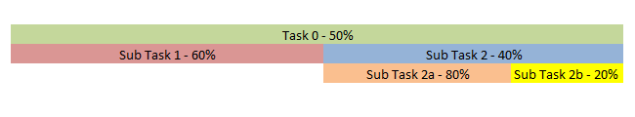

*Exhibit - 4: Task Progress*

* Explanation for the above diagram:
  + Task 0 – 50% of the whole project.
  + Sub Task 1 – 60% of Task 0.
  + Sub Task 2 – 40% of Task 0.
  + Sub Task 2a – 80% of Sub Task 2.
  + Sub Task 2b – 20% of Sub Task 2.
  + When Sub Task 2a is completed then 80% of Sub Task 2 is completed (80% of 40% of Task 0 is completed).
  + When Sub Task 2b is completed then 20% of Sub Task 2 is completed (20% of 40% of Task 0 is completed). 100% of Sub Task 2 is completed (40% of Task 0 is completed).
* If all the sub-tasks have been completed (100%), then the parent task will show as “Completed” or 100%.
* The parent task cannot be edited once all its sub-tasks have been completed.
* If a new sub-task is added, the percentage allocation of all the other sub-tasks have to be adjusted. Please refer the figure below when a new sub-task “Sub Task 2c – 20%” is added.

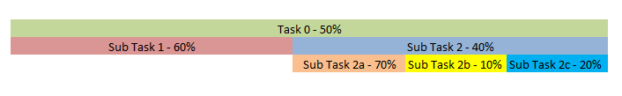

*Exhibit - 5: Task Progress (% allocation adjustment)*

* Reports and Dashboards
* Special dashboards will be available to the senior management. At present two types of dashboards will be provided:
  + A dashboard which will give a real-time view of resources working at any point of time. The dashboard will show which resource has clicked on the “Start” button and which resource has clicked on the “Stop” button for any task. Based on the “Start” or “Stop” selected, the dashboard will display real-time working status of every employee.
    - If an employee has started the work and has forgotten to stop the task, then in the report it will continue to show that this employee is working on this task. This is also applicable is the employee is on leave and/or there is weekend the following day.
    - Please look into the below example to understand a special case:
      * An employee has started a task at 8:00 pm on 01-Mar-2020 and stopped the task at 1:00 am on 02-Mar-2020.
      * The report is generated on 9:00 am on 02-Mar-2020.
      * The report will show that this employee have stared the work on 8:00 pm, 01-Mar-2020.
  + A dashboard which will display how much a resource has worked for any given duration. The duration can be as given below:
    - Daily
    - Weekly
    - Monthly
    - Quarterly
    - Half yearly
    - Annually
    - Between any date range provided
  + A dashboard which will display the Project – Module – Resource wise allocation and vice-versa. This dashboard will display which resource is allocated to which project/module at any point of time.
* Reports will be pulled basis the time spent on the task.
* Status wise list of the Tasks.
* Variance Reports.
* The reports and dashboards can be exported in excel and PDF formats.
* Reports can be viewed based on (tentative):
  + Project wise.
  + Resource wise.
  + Date wise.
  + Month wise.

# **Task Process Flow for Standalone Tasks**

* Tasks can be created which are not linked to any specific workflow or project.
* These tasks will be standalone tasks which will be created and processed independently.
* The task creator will create the task and assign it to relevant users. The assigned users will further work on the task processing.
* The assigned user can further forward the task to another user if he/she feels that the task has to be processed by someone else or needs to be done in collaboration.

# **Task Process Flow for Specific Departments**

* Tasks can be created for specific departments. E.g. Admin department, HR department, IT department etc.
* Any user can create a task for any department.
* At least one user will be mapped to every department.
* While creating a task the user will select the specific department. The user/s mapped to that department will be notified about the task. The task will also be assigned to the user/s.
* The assigned user/s will now process the task further.

# **Task Process for Specific Work Flows**

* Tasks can be created for specific projects to track the entire project lifecycle.
* To start with projects will be created in the system.
* Modules will be created in the system which will be linked to projects. Module will be the subset of a project.
* Multiple modules can be linked to a single project. But only one project can be linked to multiple modules.
* Workflows will be created separately in the system.
* Workflow will have multiple steps. E.g. for workflow steps are given below:
  + Requirement gathering
  + Design and Development
  + Testing
  + Deployment
* Project, module and workflow will now be mapped with each other.
* After the mapping is done, the workflow steps will be displayed automatically. The user/s responsible for each workflow step and the percentage completion of each workflow step can now be defined. The total percentage completion should add up to 100%.
* After the setup is saved, individual tasks pertaining to each workflow step will be created. These will be the first level tasks created against the particular module.
* User/s responsible for each workflow step will be notified about the tasks created for them. The task can also be seen in their views and/or dashboards.
* Multiple tasks can be created related to these first level tasks. These tasks will be the child tasks of the first level tasks as shown in the below diagram.

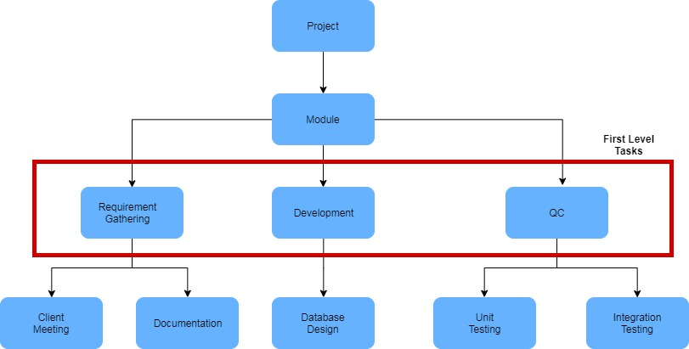

*Exhibit - 4: Task Hierarchy*

# **Timeline and effort**

# **Technology**

1. Web based application developed in ASP.NET & SQL Server.
2. Web services for sending data over intranet server.
3. Third Party integration with SMS service.

# **NOTES:**

# - Offline process is not a part of the system, but is directly related to the working logic of the system.